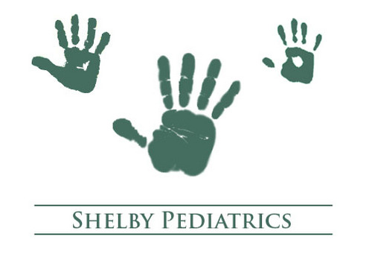

NOTICE OF PRIVACY PRACTICES
FOR

SHELBY PEDATRICS
71 MACK WALTERS ROAD
SHELBYVILLE, KY 40065
(502) 633-7337

EFFECTIVE DATE: APRIL 14, 2003

NOTICE OF PRIVACY PRACTICES
THIS NOTICE DESCRIBES HOW MEDICAL INFORMATION ABOUT YOU MAY BE USED AND DISCOLSED AND HOW YOU MAY GET ACCESS TO THIS INFORMATION. PLEASE READ IT CAREFULLY.
Shelby Pediatrics is dedicated to protecting you medical information. We are required by law to maintain the privacy of protected health information and to provide you with this Notice of our legal duties and privacy practices with respect to protected health information. Shelby Pediatrics is required by law to abide by the terms of this Notice.
HOW YOUR MEDICAL INFORMATION WILL BE USED AND DISCLOSED.
We will use your medical information as part of rendering patient care. For example, your medical information may be used by the provider or nursing staff treating you, by the business office to process your payment for the services rendered and by administrative personnel reviewing the quality of care you receive.
We may also use and/or disclose your information in accordance with federal and state laws for the following purposes:
Appointment Reminders.
We may contact you to provide appointment reminders.
Treatment Information.
We may contact you with information about treatment alternatives or other health related benefits and services that may be of interest to you.
Disclosure to Department of Health and Human Services.
We may disclose medical information when required by the United States Department of Health and Human Services as part of an investigation or determination of our compliance with relevant laws.
Family and Friends.
Unless you object, we may disclose your medical information to family members, a personal representative or another person responsible for your care, of your location, general condition of health.
Disaster Relief.
We may disclose your medical information to a public or private entity, such as the American Red Cross, for the purpose of coordinating with that entity to assist in disaster relief efforts.
Health Oversight Activities.
We may use or disclose your medical information for public health activities, including the reporting of disease, injury, vital events and the conduct of public health surveillance, investigation and/or intervention. We may disclose your medical information to a health oversight agency for oversight activities authorized by law, including audits, investigation, inspections, licensure or disciplinary action, administrative and/or legal proceedings.
Abuse or Neglect.
We may disclose your medical information when it concerns abuse, neglect or violence to you in accordance with federal and state law.
Legal Proceedings.
We may disclose your medical information in the course of certain judicial or administrative proceedings.
Law Enforcement.
We may disclose your medical information for law enforcement purposes or other specialized government functions.
Coroners, Medical Examiners and Funeral Directors.
We may disclose your medical information to a coroner, medical examiner or funeral director.
Organ Donation.
If you are an organ donor, we may disclose your medical information to an organ donation and procurement organization.
Research.
We may use or disclose your medical information for certain research purposes if an Institutional Review Board or privacy board has altered or waived individual authorization, the review is preparatory to research or the research is on only decedent’s information
Public Safety.
We may use or disclose your medical information to prevent or lessen a serious threat to the health or safety of another person or to the public.
Worker’s Compensation.
We may disclose your medical information as authorized by laws relating to worker’s compensation or similar programs.
Business Associates.
We may disclose your health information to a business associate with whom we contract to provide services on our behalf. To protect your health information, we require our business associates to appropriately safeguard the health information of our patients.
AUTHORIZATIONS:
We will not use or disclose your medical information for any other purpose without your written authorization. Once given, you may revoke your authorization in writing at any time. To request a Revocation of Authorization form, you may contact:
Shelby Pediatrics
71 Mack Walters Road
Shelbyville, KY 40065
(502) 633-7337
YOUR RIGHTS REGARDING YOUR MEDICAL INFORMATION:
You have the following rights with respect to your medical information:
- You may ask us to restrict certain uses and disclosures of your medical information. We are not required to agree to your request, but if we do, we will honor it.
- You have the right to receive communication from us in a confidential manner.
- Generally, you may inspect and copy your medical information. This right is subject to certain specific exceptions, and you may be charged a reasonable fee for any copies of your records.
- You may ask us to amend your medical information. We may deny your request for certain specific reasons. If we deny your request, we will provide you with a written explanation for the denial and information regarding further rights you may have at that point.
- You may have the right to receive an accounting of the disclosures of your medical information made by Shelby Pediatrics following April 13, 2003, except for disclosures for treatment, payment or healthcare operations, disclosures which you authorized and certain other disclosure types.
- You may request a paper copy of this Notice of Privacy Practices for Protected Health Information.
- You have the right to complain to us and/or the United States Department of Health and Human Services if you believe that we have violated your privacy rights. If you choose to file a complaint, you will not be retaliated against in any way. To complain to us, please contact:
Shelby Pediatrics
71 Mack Walters Road
Shelbyville, KY 40065
(502) 633-7337

